**Convolution Neural Networks:**

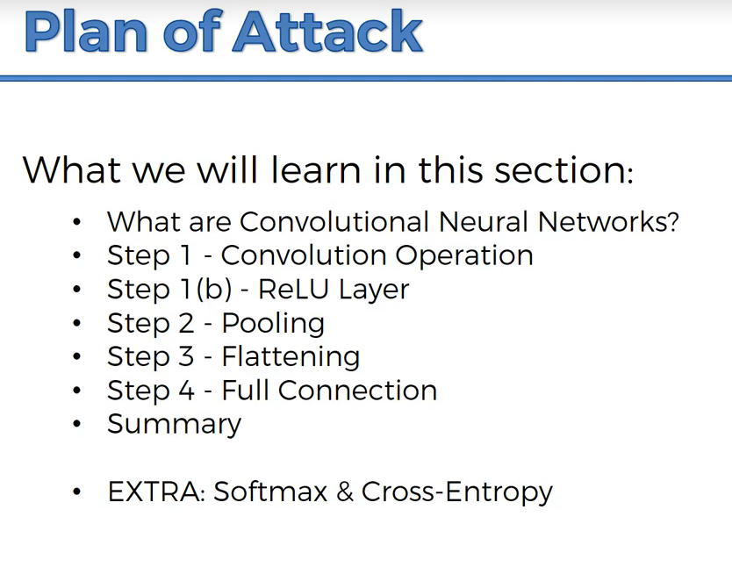

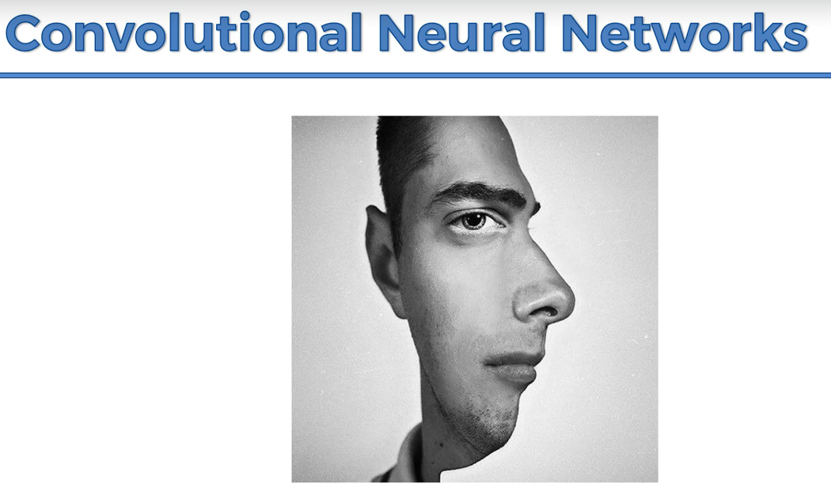

Brain will pick the features based on which the brain classifies the image.

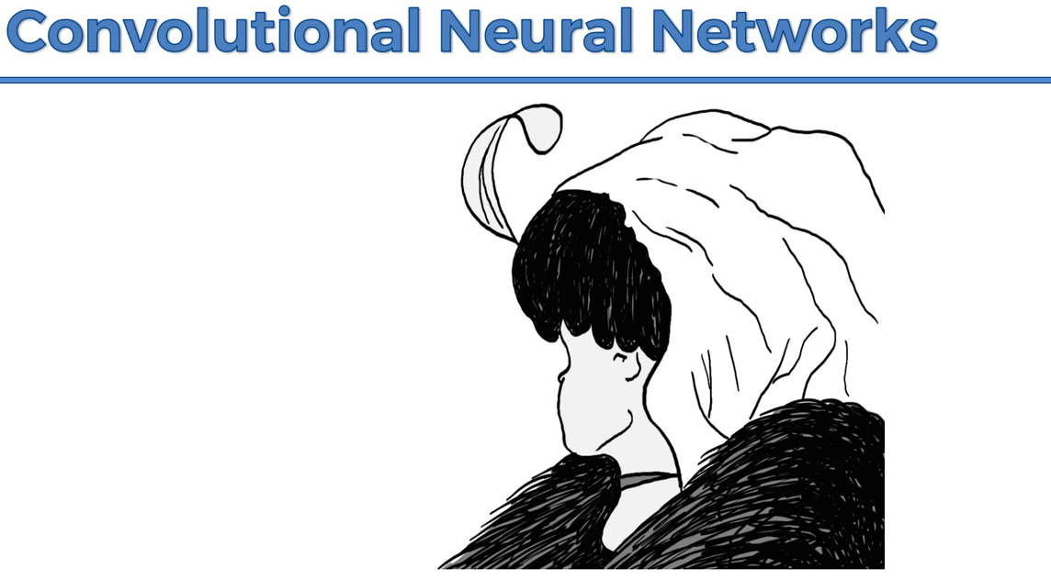

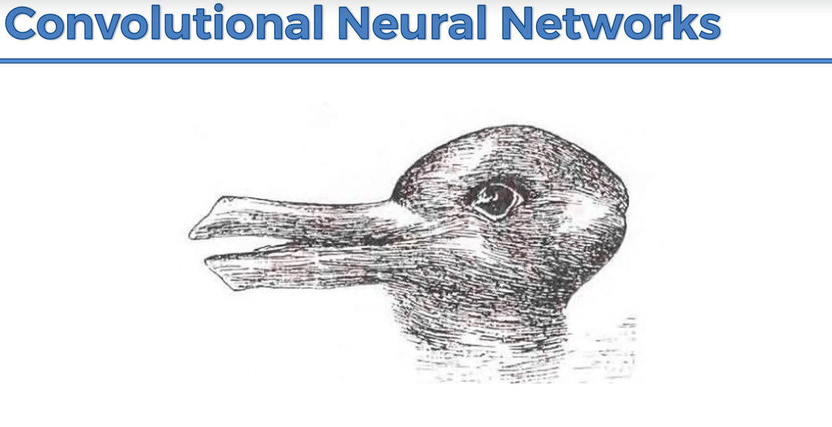

Brain is trying to understand the image by switching the eye in the image.

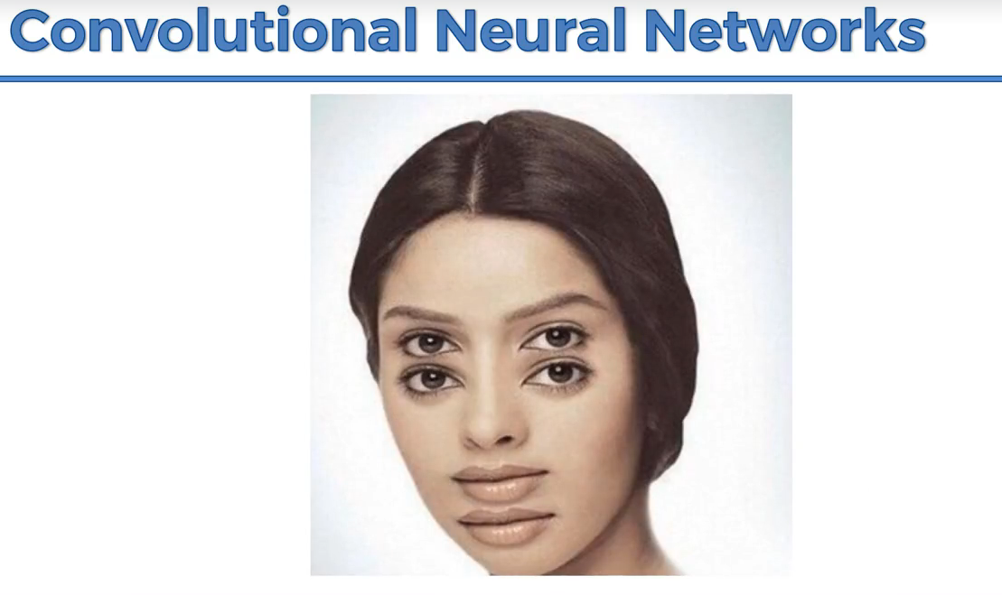

CNN will process the images and predict the image.

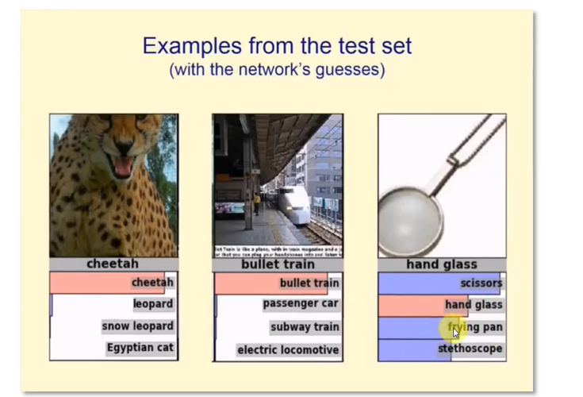

**Working of CNN:**

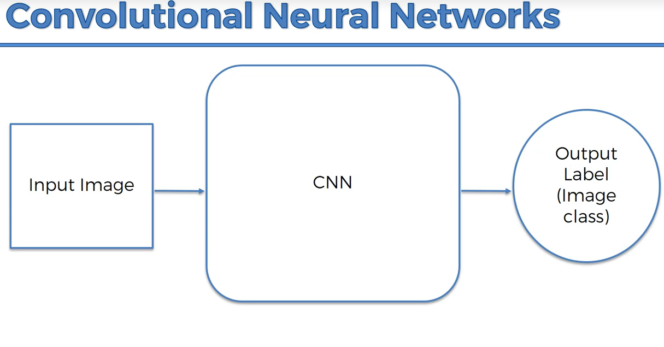

CNN can recognize emotions,

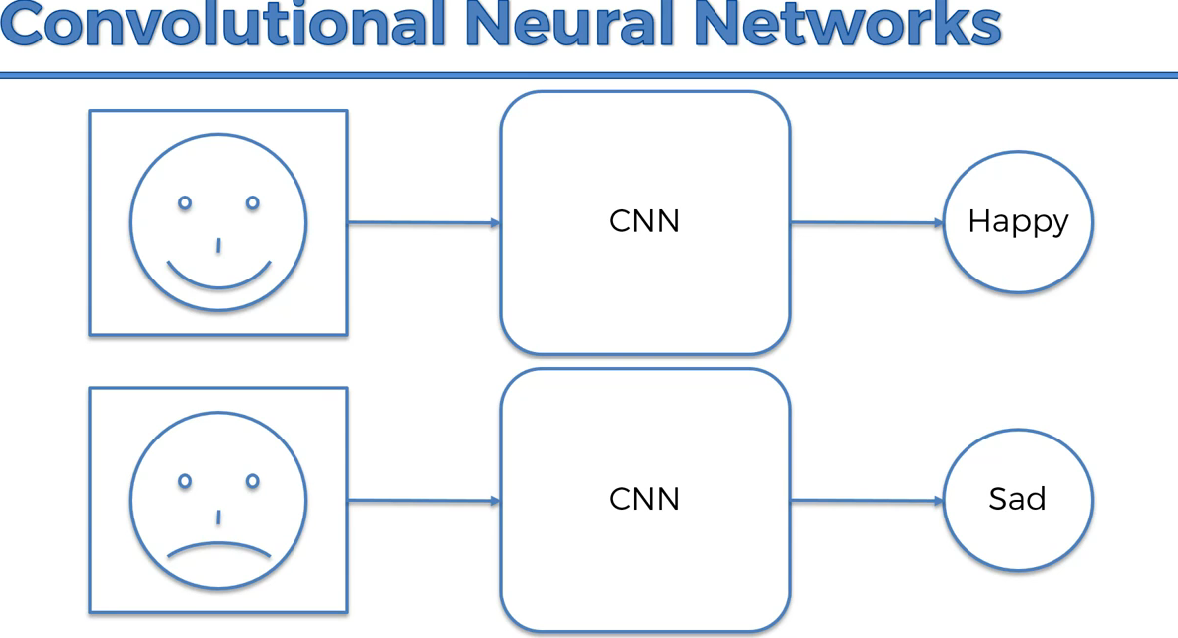

Sometimes if the image is not clear, CNN accuracy can reduce like human brain

**Drill down of CNN working:**

Colored image🡪3d(R,G,B)

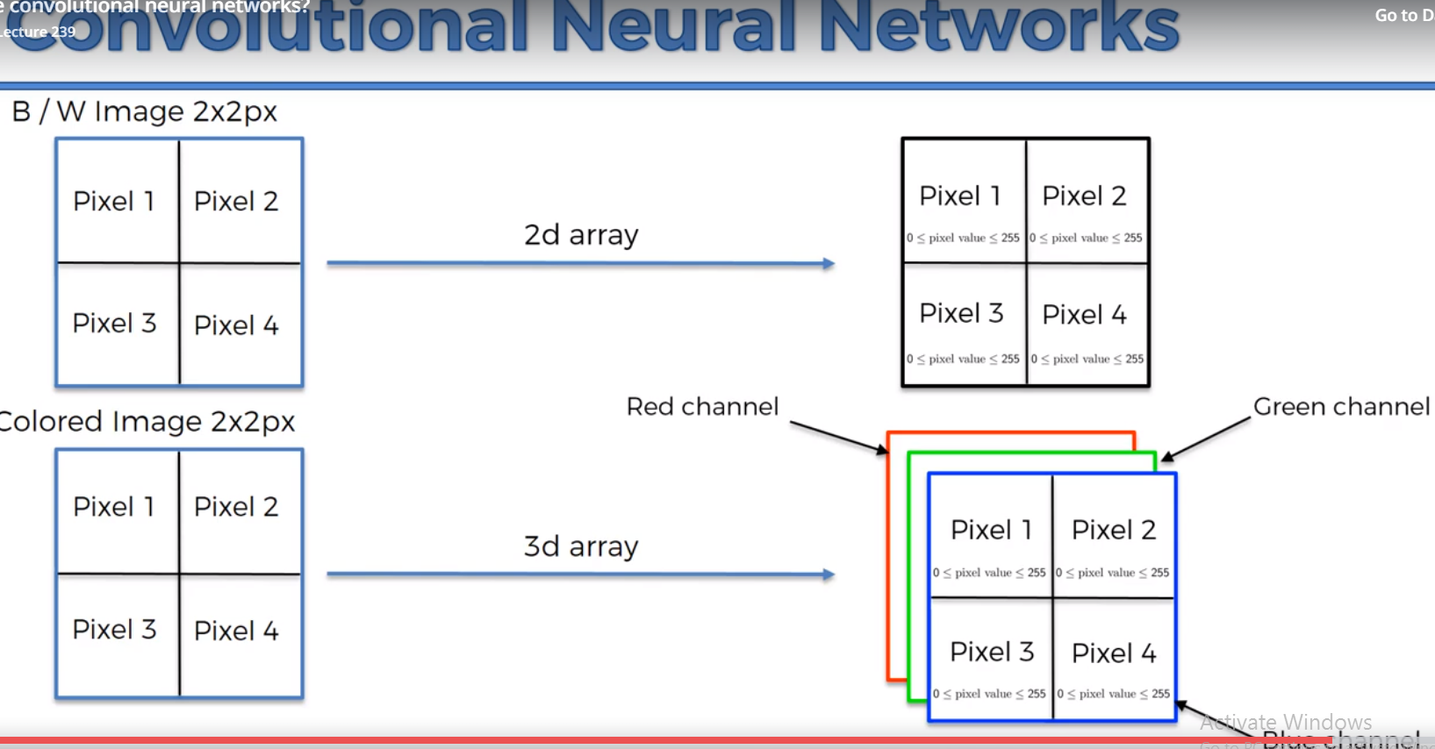

Example:

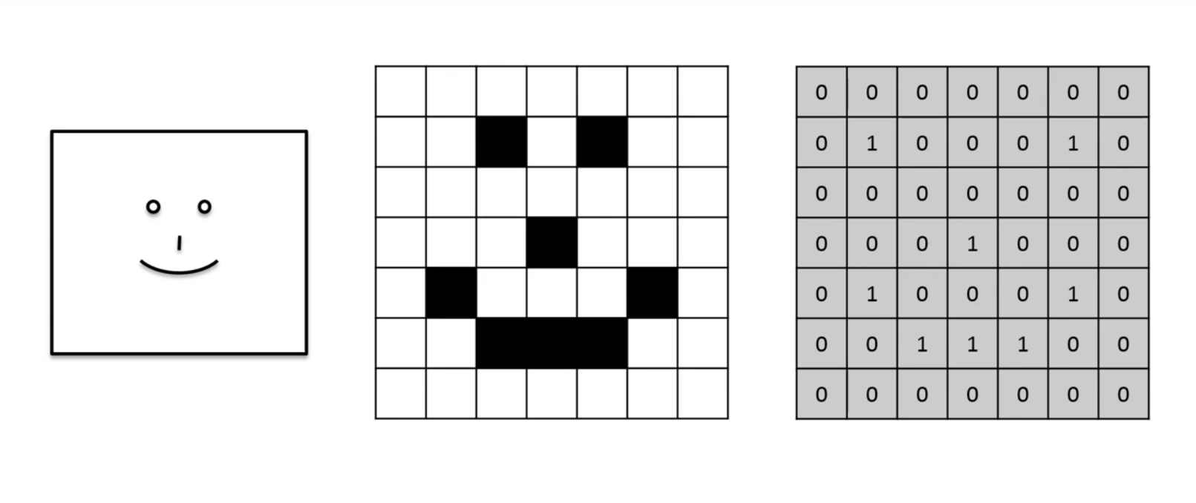

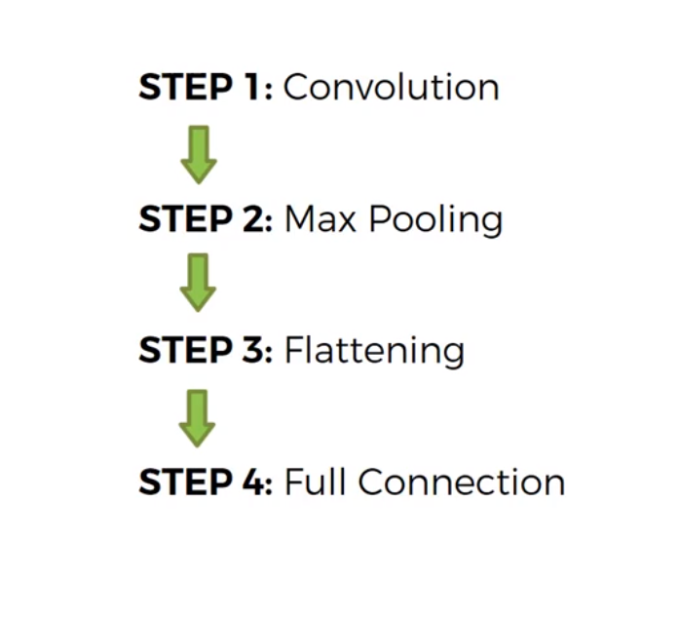

Step 1: Convolution

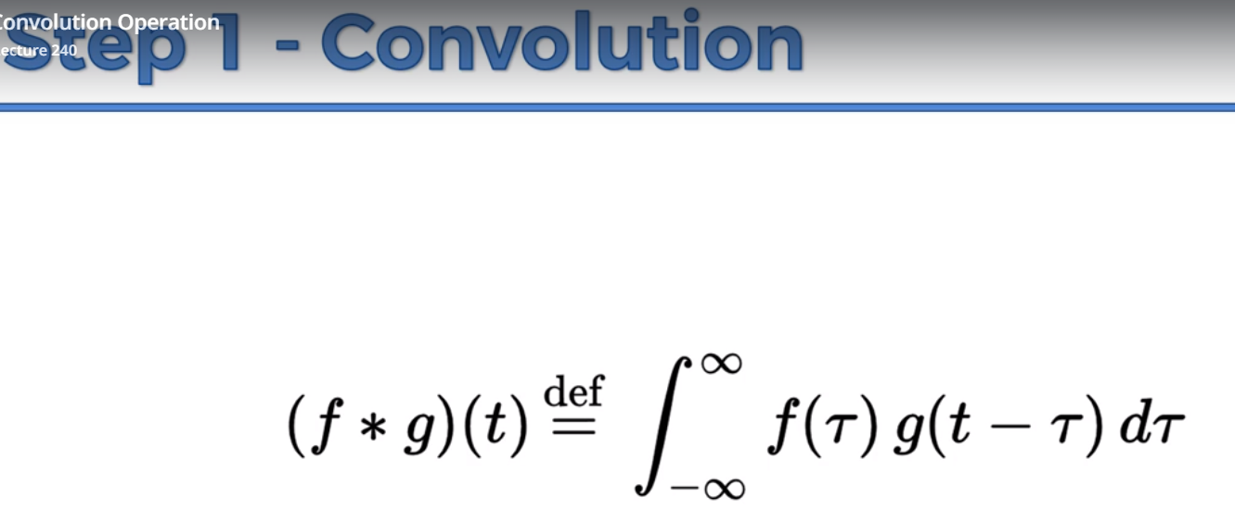

Feature detector is also called as filter or kernel

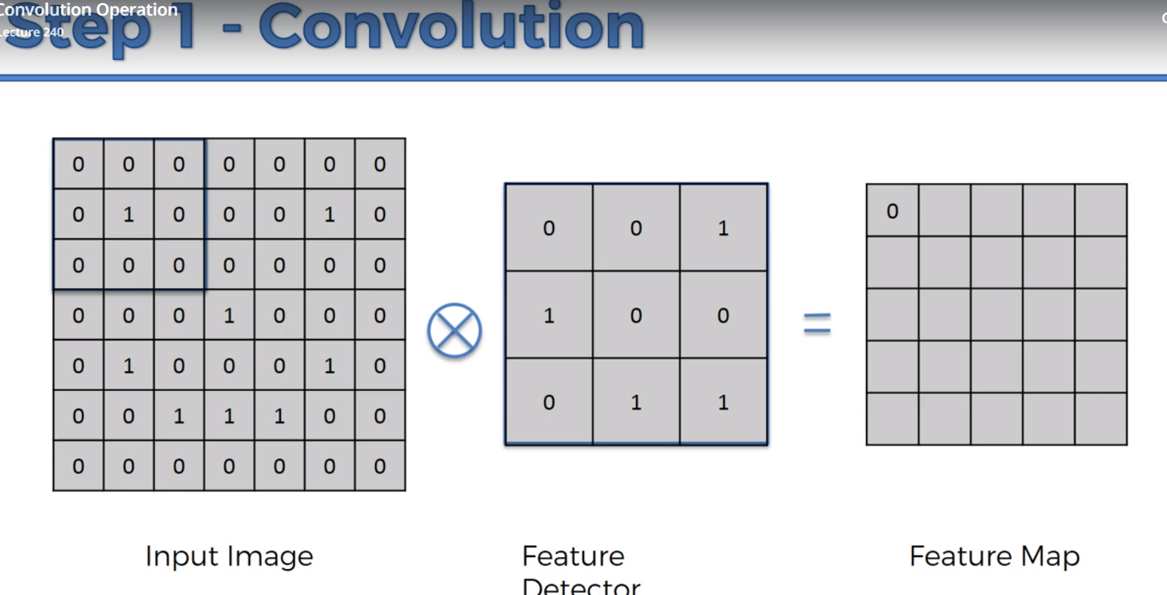

Nothing matched up so 0,

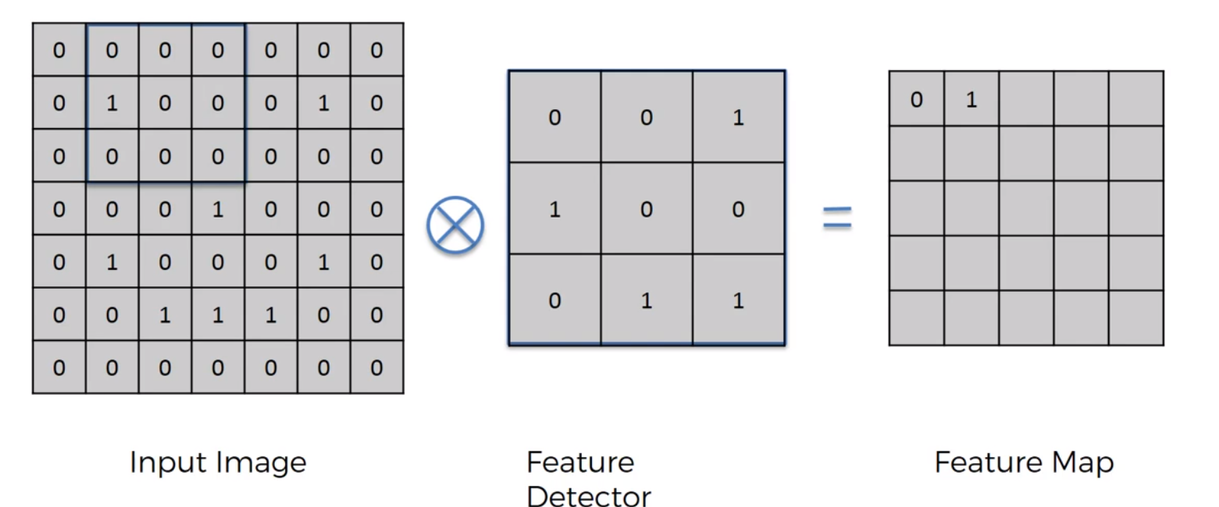

Matching is there hence 1 in feature mapping

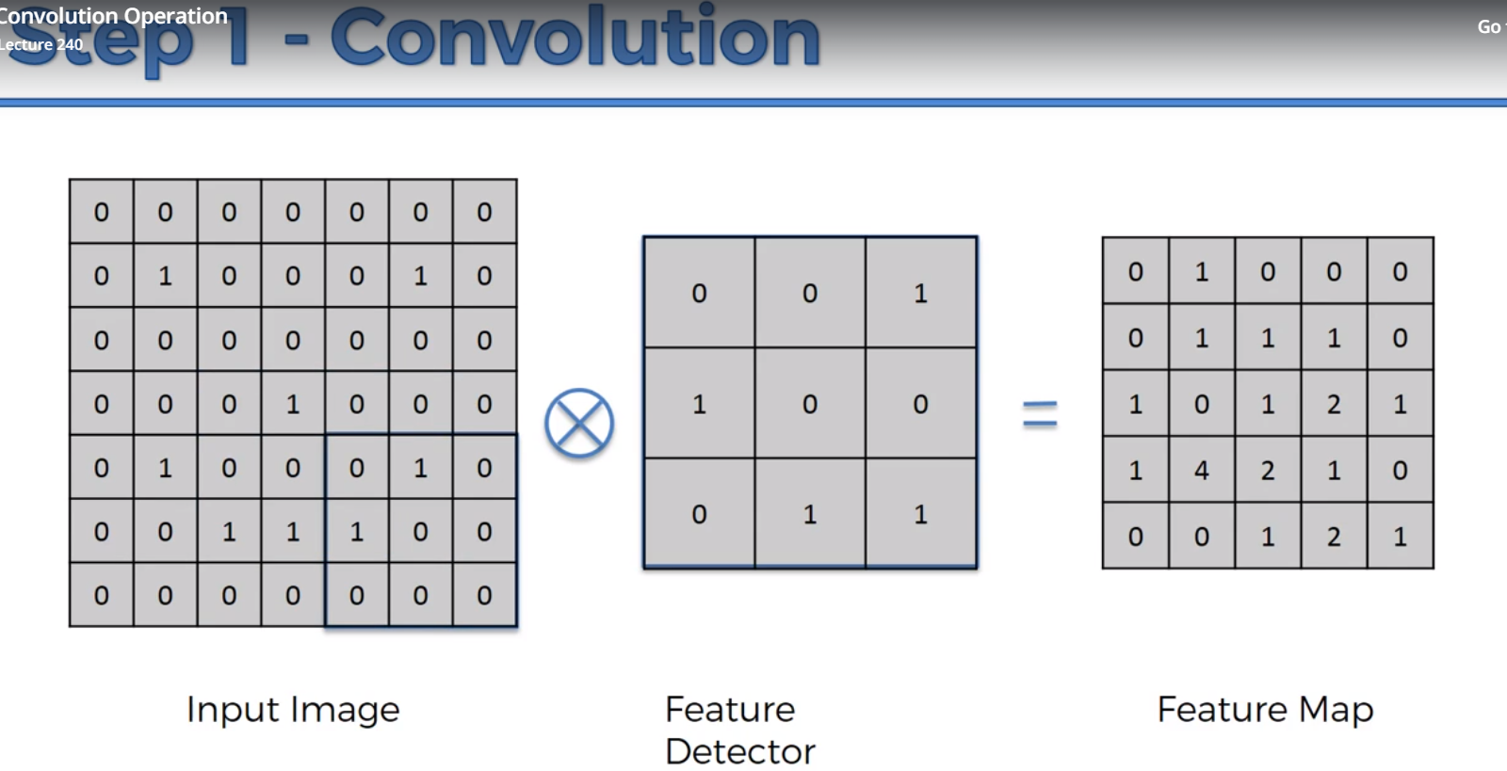

1. Input image size is reduced when compared to feature map using feature detector. It will make it faster.

2. Feature Detector will lose use some info, but that is ok. Every single pixel is not important, the maximum matching is we are looking for(feature mapping helps us on it).

We use multiple feature map to get the convolution layer

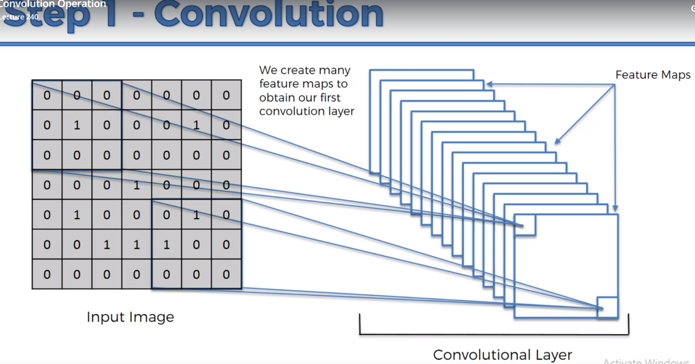

Example:

Sharpen, reduces the pixels around 5

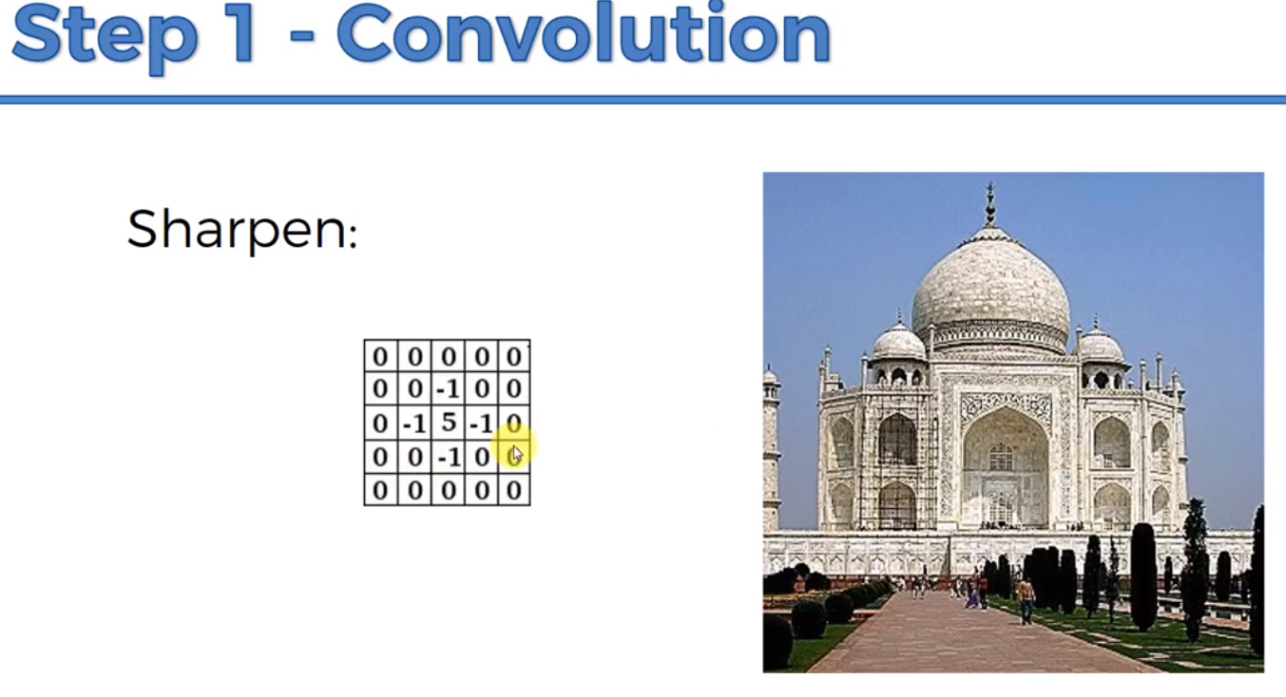

Blur makes it equal significance,

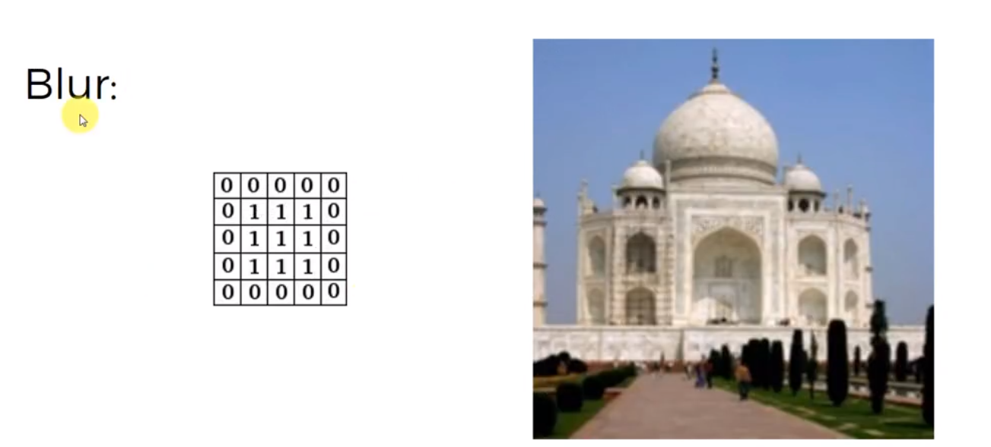

Edge Enhance,

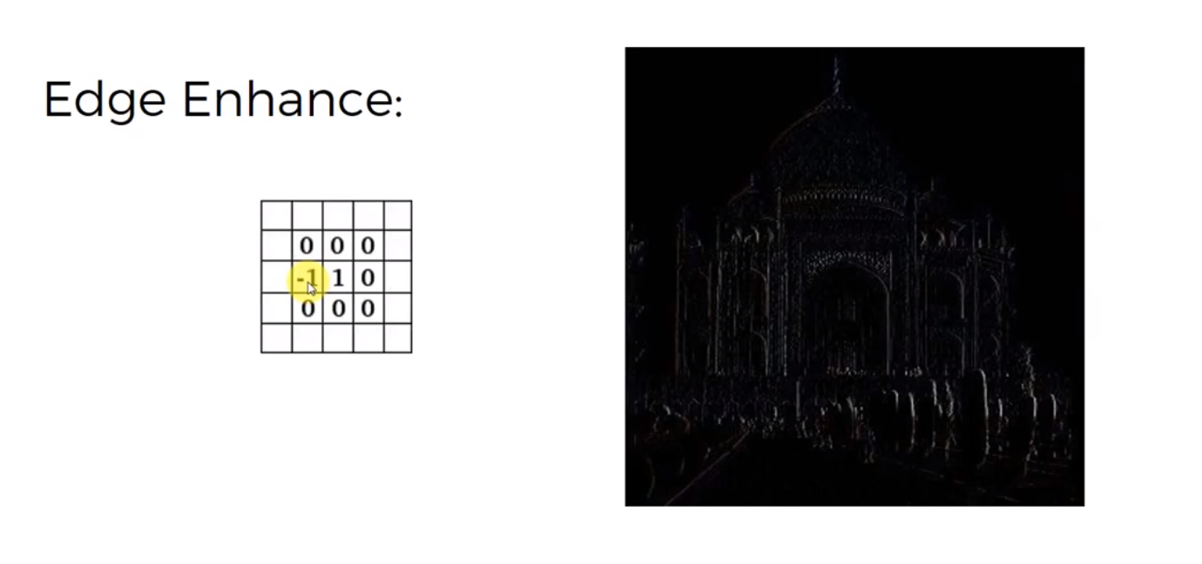

Edge detect is import in CNN,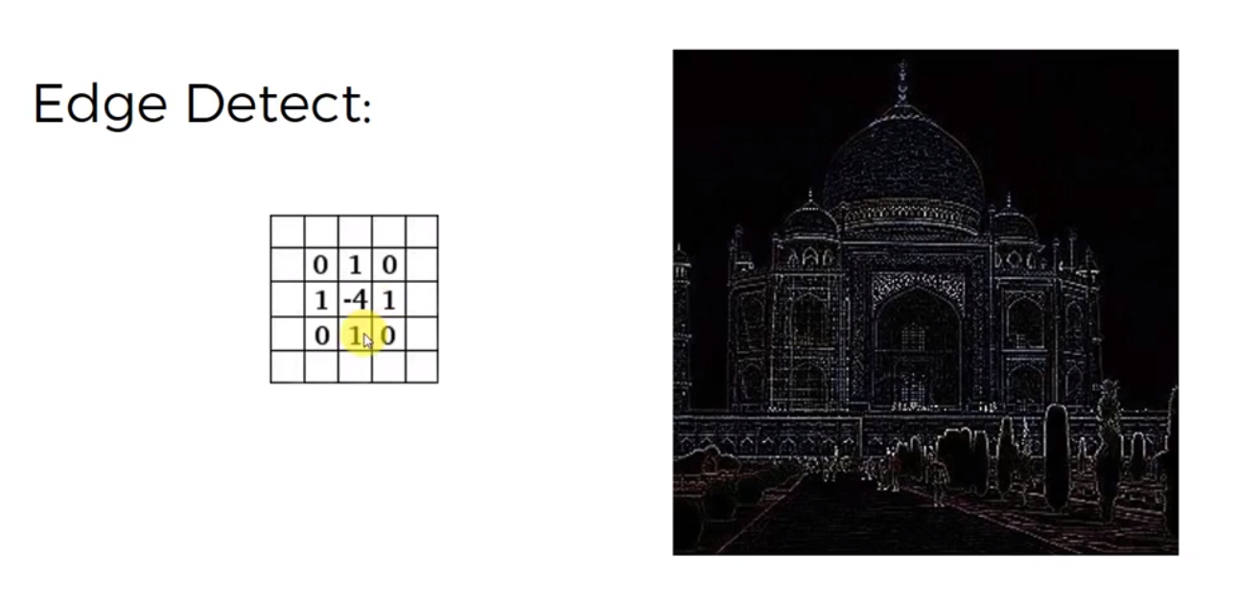

Final Example,

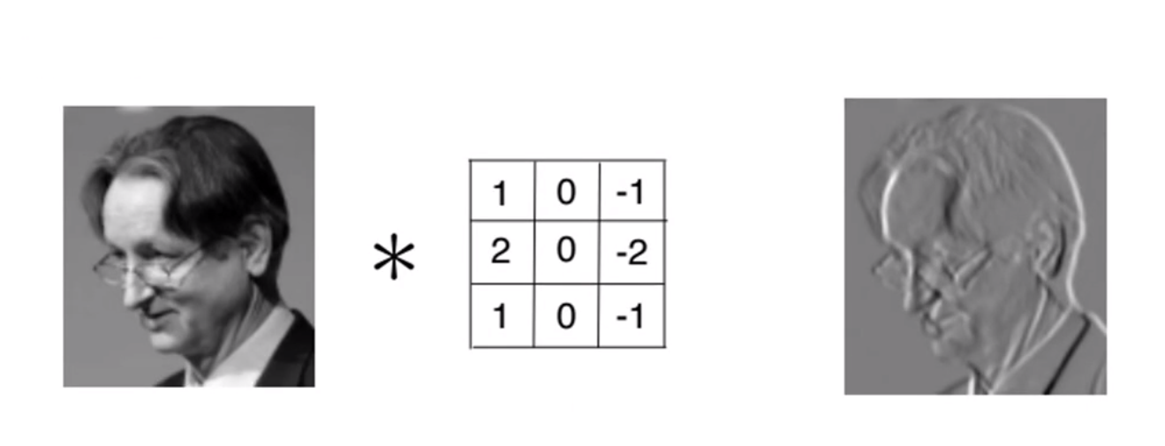

**Step 1(B)- ReLU Layer:**

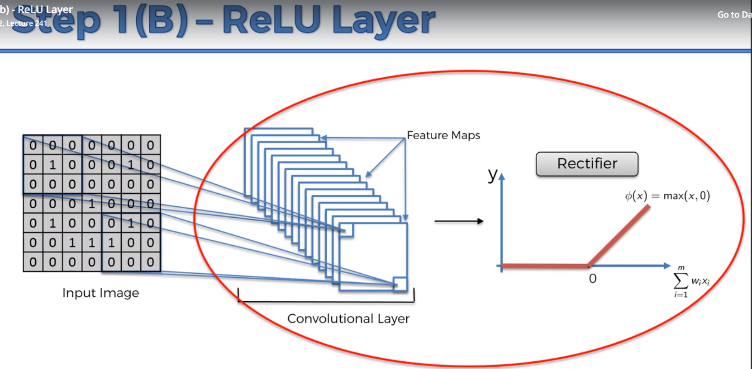

To increase non-linearity because, images are non-linear (border, color).

Let us consider the below image,

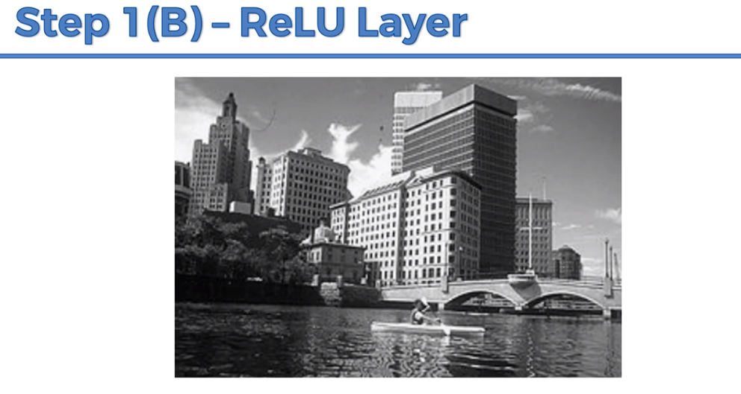

When we apply feature detector(it has pos and neg) then,

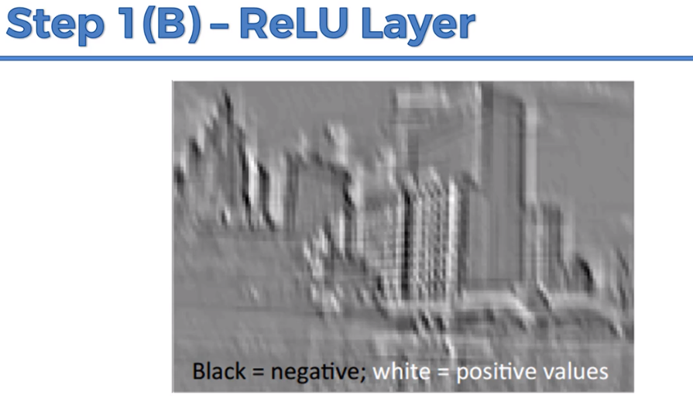

The rectifier will remove all the black and gives, non-negative values,

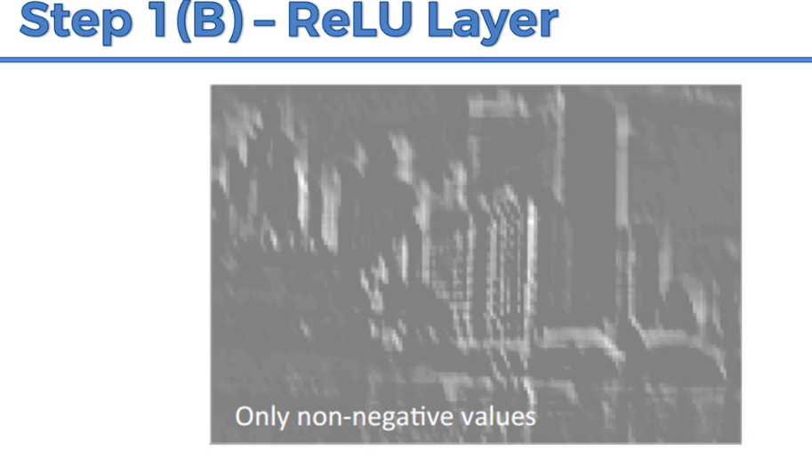

Benefits, it will remove shadows in the building (breaking up the linearity)